As we kick of the Spring Soccer Season, Milton Soccer would like to remind players and families about a few things before the season begins.

Milton Soccer Code of Conduct
Milton Soccer’s goal is to ensure soccer remains a fun and safe environment in which players can learn and enjoy the game of soccer. An emphasis on fair play and respect for all participants is a primary element of our mission. Click on the title to review the code of conduct in its entirety.

BAYS RESPECT Statement
The philosophy of BAYS is to provide an atmosphere of good sportsmanship to encourage all to compete, learn, and enjoy the game of soccer. Unfortunately, BAYS has seen more incidents of racially-charged, offensive, hurtful, and inappropriate language/actions than in the past. BAYS hopes that by emphasizing RESPECT, it can improve the game environment.

BAYS Zero Tolerance Policy
Refrain from directing ANY comments to the referees. Bays has tightened up its policy. If a side line has been found making comments about the referee calls, an individual or even an entire sideline can be required to miss a game due. Please be respectful.

Families & Players
- Discuss the importance of RESPECT and sportsmanship: Respect for opponents, teammates, coaches, officials, self, and the game.
- Familiarize yourself with the BAYS rule book.
- Continue to cheer and support ALL good soccer on the field.

PARKING at FLATLEY/ MILTON HEALTH CENTER
Please follow directions below when parking:
- Please park in designated parking lots ONLY, which is the parking to the left as you enter from Neponset Valley Parkway or behind the building. Any spots outside of that are off limits and potentially your car will be towed.
- Drop-offs in front of the building ONLY.

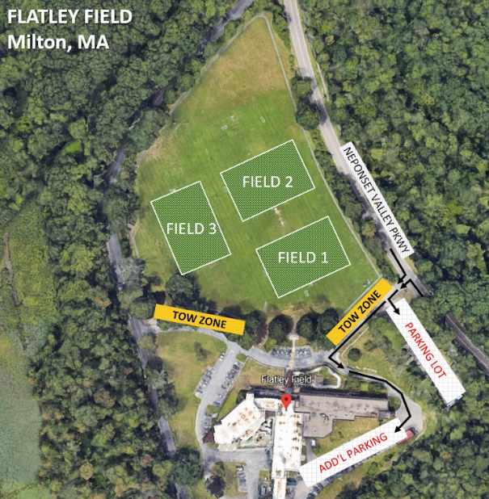

PARKING at Point 32
Fields are located at the southern end of the compound. Parking is available in the garage, not along the side of the road or grass.

PLEASE STAY OFF THE PATIO AND FOUNTAIN WALL. Parents and coaches please keep an eye on your players at all times. If someone gets hurt field access will be suspended immediately.

We hope all have an amazing Spring Soccer Season!

Thank you,
Milton Soccer

