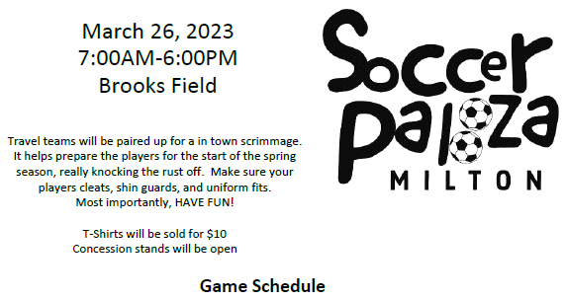
Hour | FIELD 1 | FIELD 2 | FIELD 3 | FORMAT
7:00 AM - 7:55 AM | B3A v B3B:  United v Atletico | B3C v B3D:  Independence v Galaxy | B3E v B3F:  Spartans v Guardians | 7v7
8:00 AM - 8:55 AM | G3A v G3B:  Gryphons v Pegasi | G3D v G3E:  Phoenixes v Banshees | G3F v G3G:  Harpies v Pixies | 7v7
9:00 AM - 9:55 AM | G3C v G4E:  Sirens v Gotham | G4A v G4B:  Breakers v Freedom | G4C v G4D:  Highlanders v Jaguars | 7v7
10:00AM - 10:55 AM | B4A v B4B:  Celtic v Gunners | B4C v B4D:  Dynamo v Strikers | B4E v B4F:  Dragons v Manta Rays | 7v7
11:00AM - 11:55 PM | G4F v G4G:  Lynx v Villa | G5A v G5B: Red Dragons v Red Stars | B5A v B6B:  Red Tide v Wildcats | 7v7
12:00PM - 12:55 PM | G5D v G5E:  Comets v Gold Pride | B5B v B5C:  Celestials v Wizards | B5D v B5E: Metrostars v Big Red Machine | 7v7
1:00 PM - 1:55 PM | G5C v G6F:  Reign v Spirit | G6A v G6B:  Stars v Cardinals |  | 9v9
2:00 PM - 2:55 PM | B6A v B6B:  Rovers v Wildcats | B8E v B6C: Olympians (8) v Wanderers (6) |  | 9v9
3:00 PM - 3:55 PM | G6D v G6E:  Dash v Sky Blue | G6C v G8D:  Flash v Thorns (7) |  | 9v9
4:00 PM - 4:55 PM | B8A v B8B: Red Storm (8) v Elephants (8) | B8C v B8D:  Maverick (7) v FC (7) |  | 9v9
5:00 PM - 5:55 PM | G8A v G8C:  Wild (8) v Pride (7) | G8B v G8E:  Select (8) v Royals (8) |  | 9v9

